## Video Source: [2 Quick Methods for the IELTS Speaking 1-Minute Preparation Time](https://www.youtube.com/watch?v=wTePj4_qGLE)

## [Understand IELTS Speaking in JUST 9 Minutes!](https://www.youtube.com/watch?v=MowXdaxK0fQ)

## Method 1:

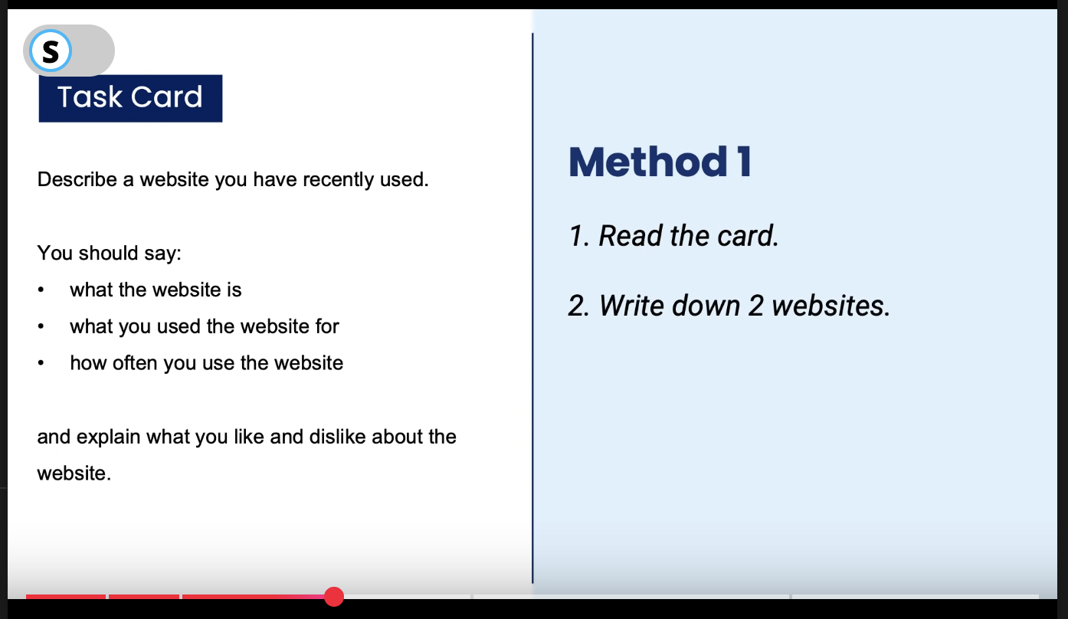

## Method 2: Use the PPF(Past Presenºt Future) method

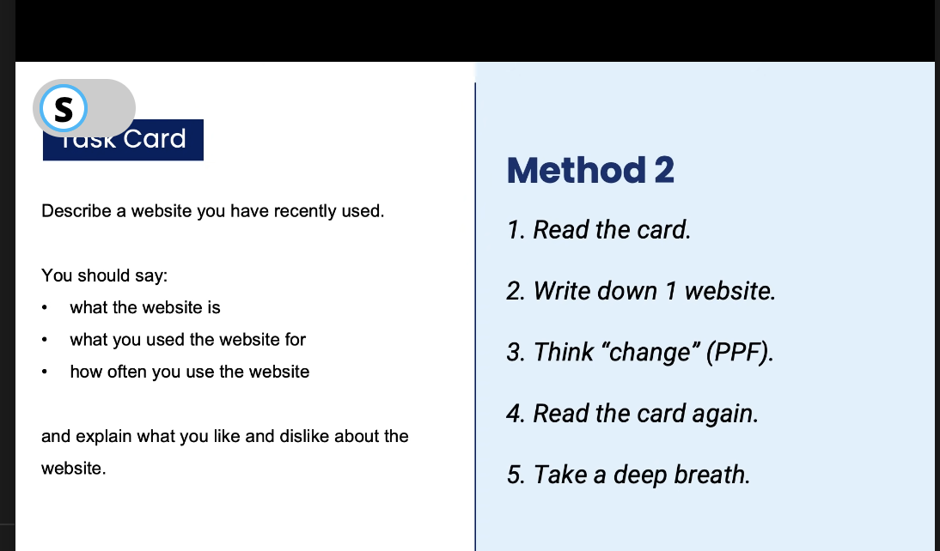

## IELTS Speaking Structure:



Mandatory Questions:

Do you live in an apartment or a house?

Are you a student or do you work?

Then questions would be generic:

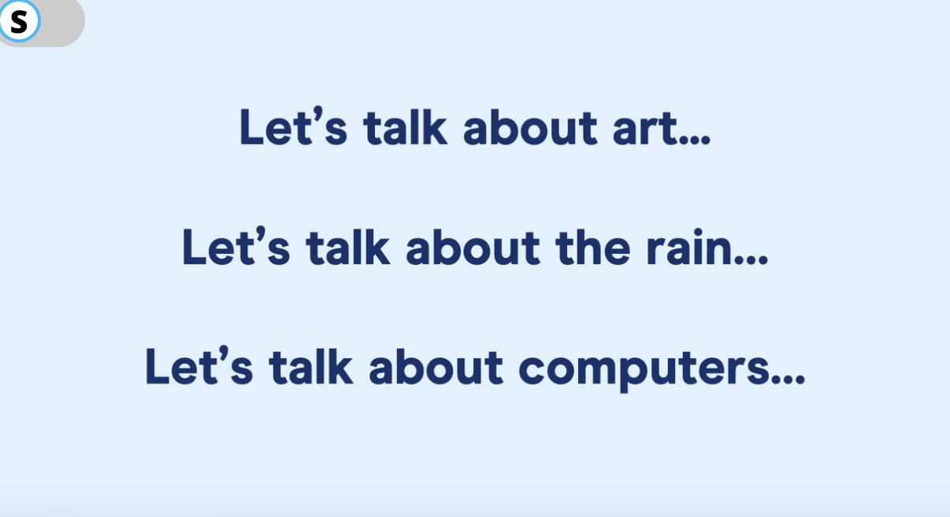

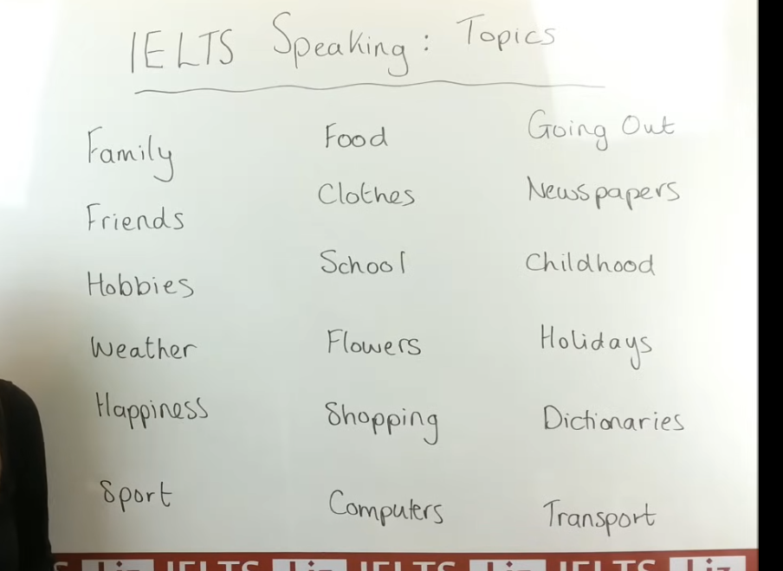

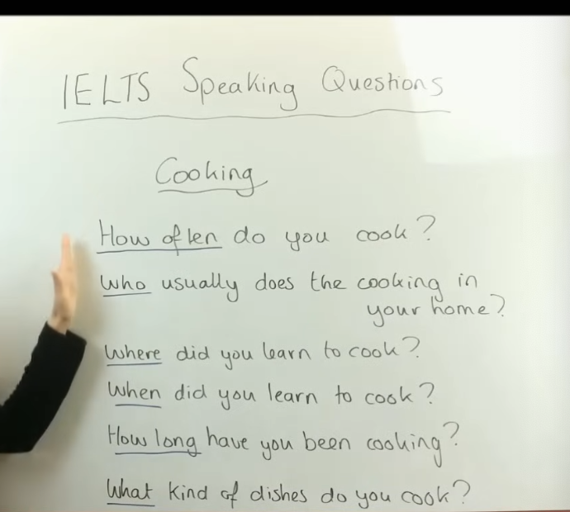

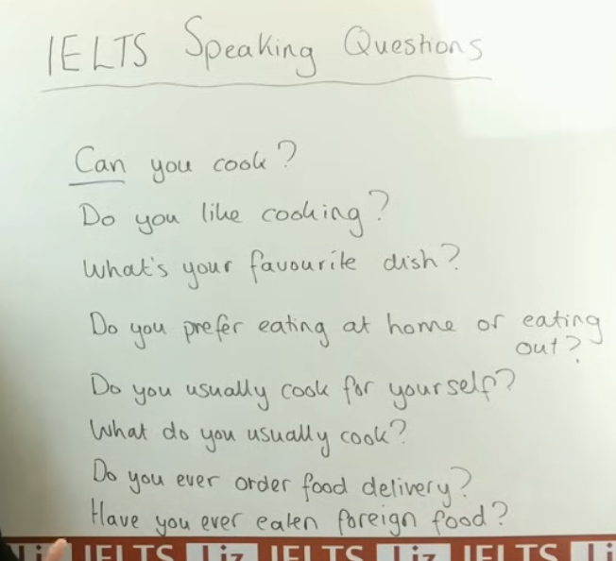

Listen for the starting keywords such as Can, What, When, Have, etc.

Like for example, “Did” informs you that it's from the past tense.

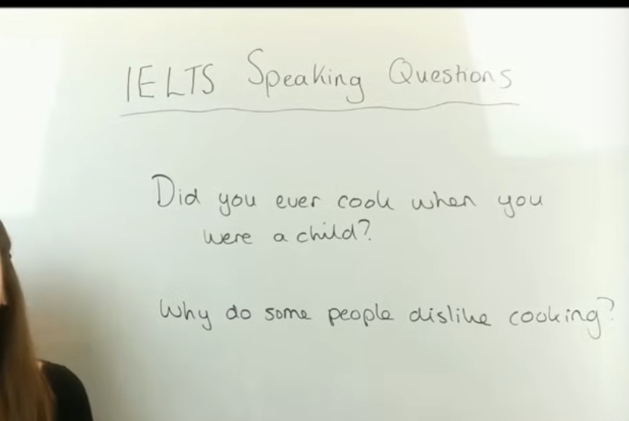

For example, in the 2nd question, you may provide some points or suggestions on why people dislike cooking



